1. Gauge: To show the number of rows of data.

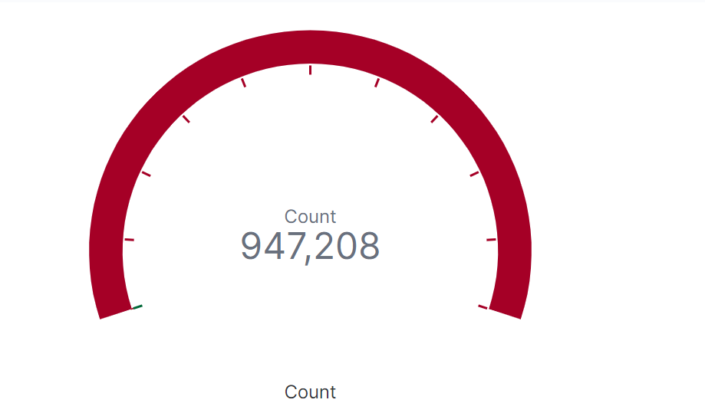

1. The count of people receiving different kinds of assistance in a fire incident according to each of the boroughs in NYC.

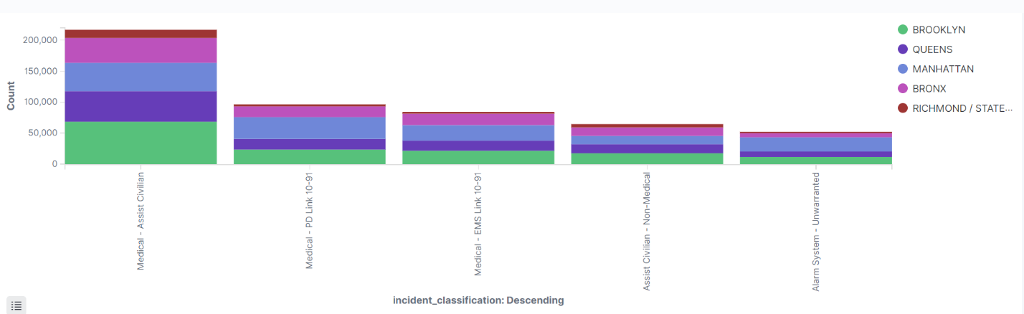

1. The graph describes how the fire information received(via a phone or Private Fire Alarm etc) according to each of the boroughs in NYC.

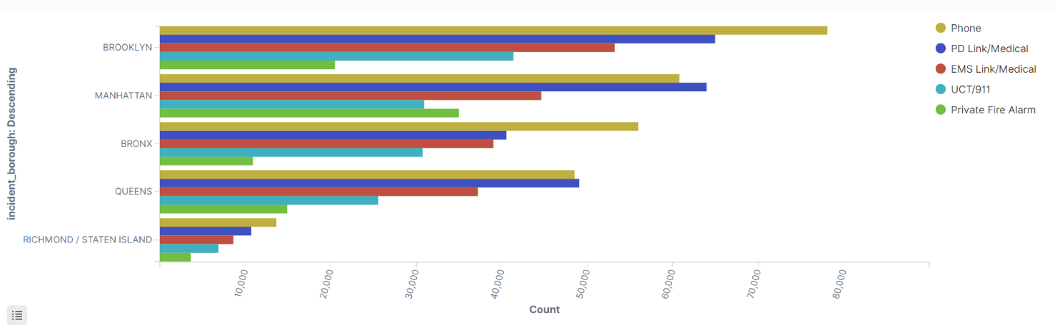

1. This doughnut pie chart shows the percentage of fire incidents according to each of the boroughs in NYC.

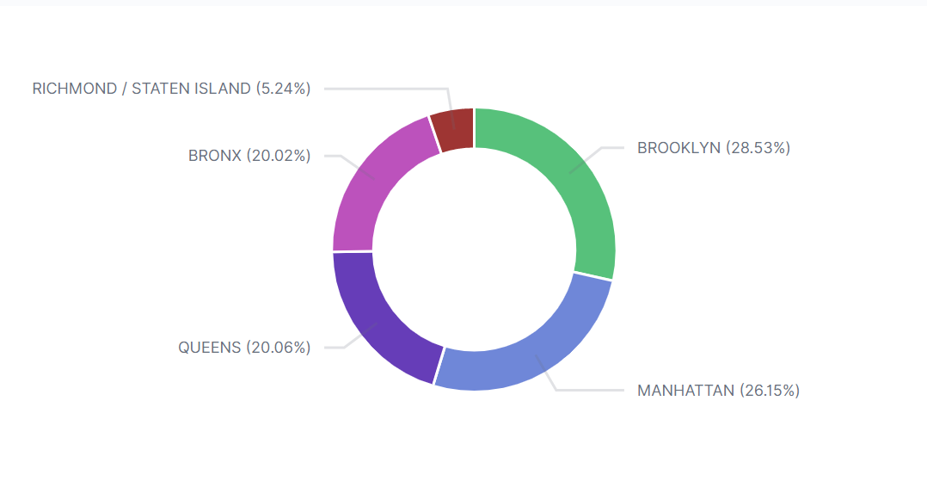

1. This line chart shows us the average of the fire incidents over time from September 2008 to July 2009.

